Question : 1
Create two NumPy arrays representing the daily step counts of two friends over a week and use element-wise addition, subtraction, multiplication, and division to compare their activity levels :

import numpy as np
friend1 =np.array([5000,7000,8000,6500,9000,7500,10000])
friend2 =np.array([4500,6500,8500,6000,8000,7000,9500])
print(f"Addition:{friend1 + friend2}")
print(f"Subtraction:{friend1 - friend2}")
print(f"Multiplication:{friend1 * friend2}")
print(f"Division:{friend1 / friend2}")
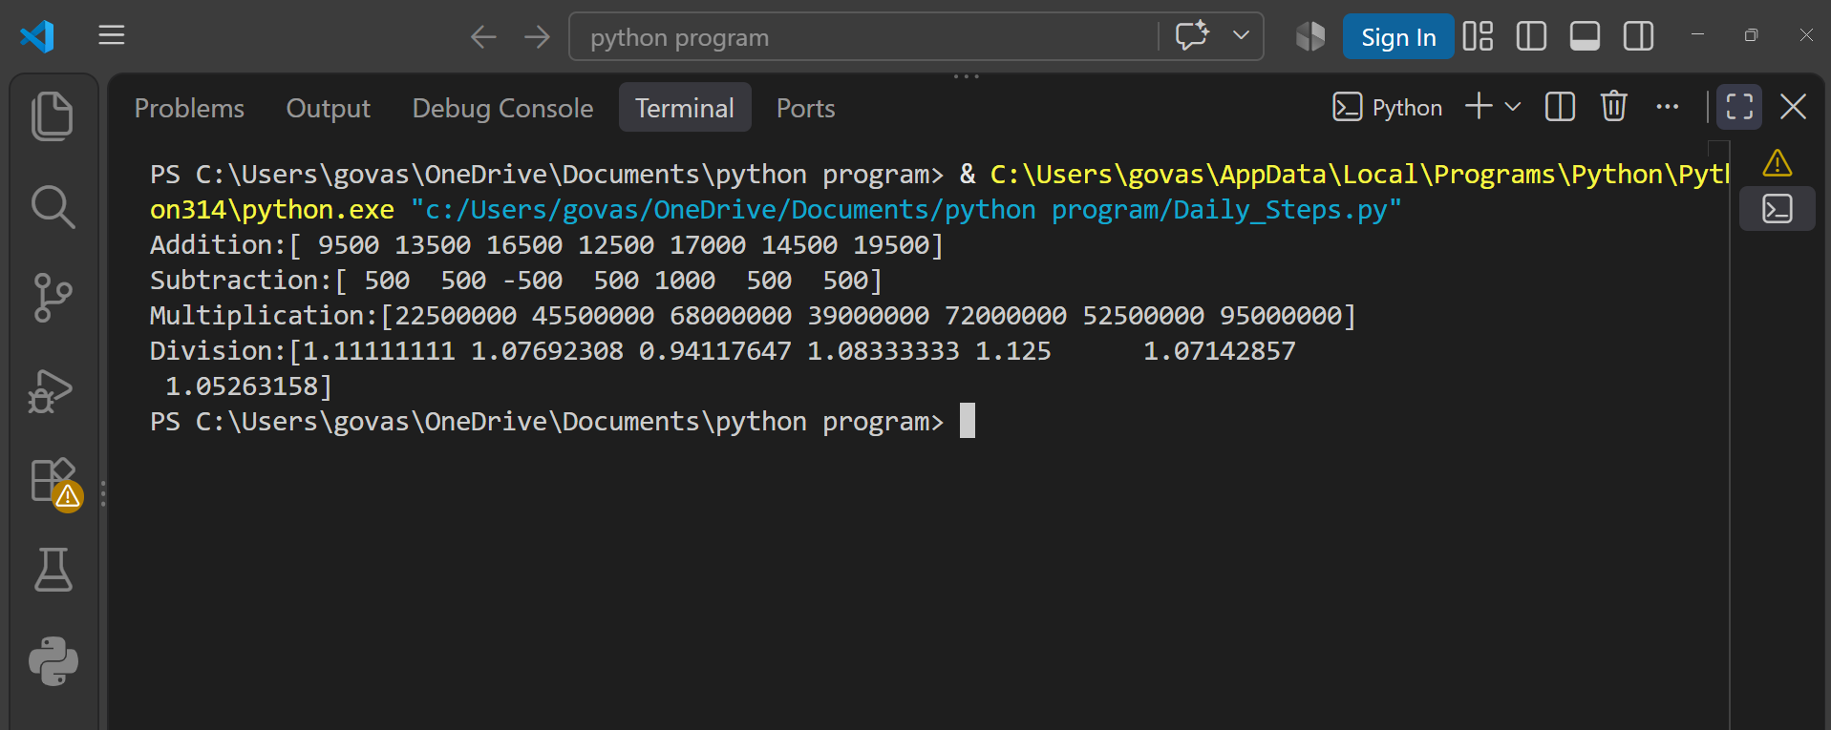

Question : 2
Simulate a Spotify-like 'Recommended Songs' feature: Given two 3x3 matrices representing user-song interaction scores (user preferences and song popularity), use dot() and matmul() to compute the final recommendation matrix and explain the difference between the two results :

import numpy as np
user_preferences =np.array([
[5,3,2],
[4,5,1],
[2,4,5]
])
song_popularity =np.array([
[4,2,3],
[3,5,2],
[2,3,5]
])
dot_result =np.dot(user_preferences,song_popularity)
matmul_result =np.matmul(user_preferences,song_popularity)
print("Using dot():")
print(dot_result)
print("\nUsing matmul():")
print(matmul_result)

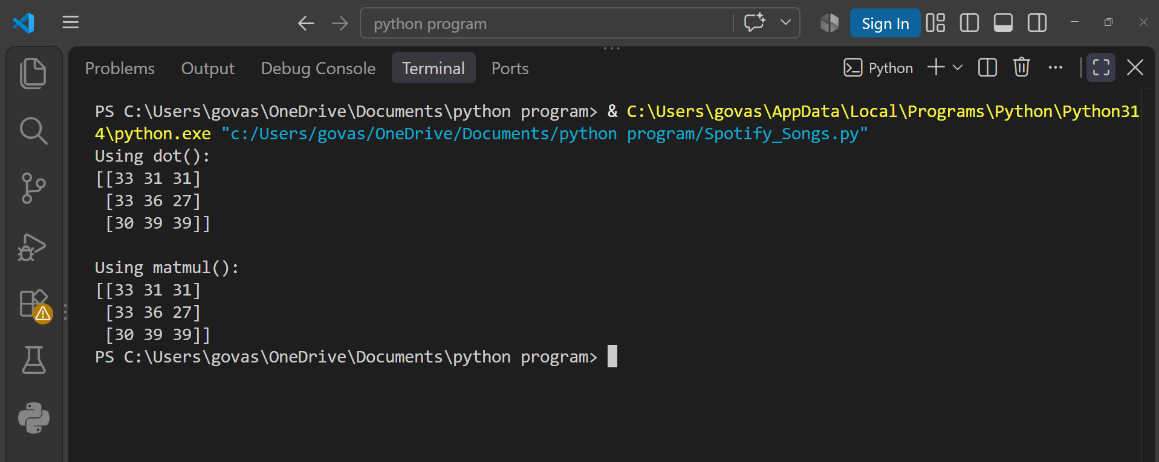
Question : 3
Given a 4x4 NumPy matrix representing the pixel brightness of a small Instagram image, use transpose (T) to rotate the image and then calculate the mean, median, standard deviation, and variance of the pixel values :

import numpy as np
image =np.array([
[10,20,30,40],
[50,60,70,80],
[90,100,110,120],
[130,140,150,160]
])
rotated_image =image.T
print("Original Image:")
print(image)
print("\nTransposed Image:")
print(rotated_image)
print("\nMean:",np.mean(image))
print("Median:",np.median(image))
print("Standard Deviation:",np.std(image))
print("Variance:",np.var(image))
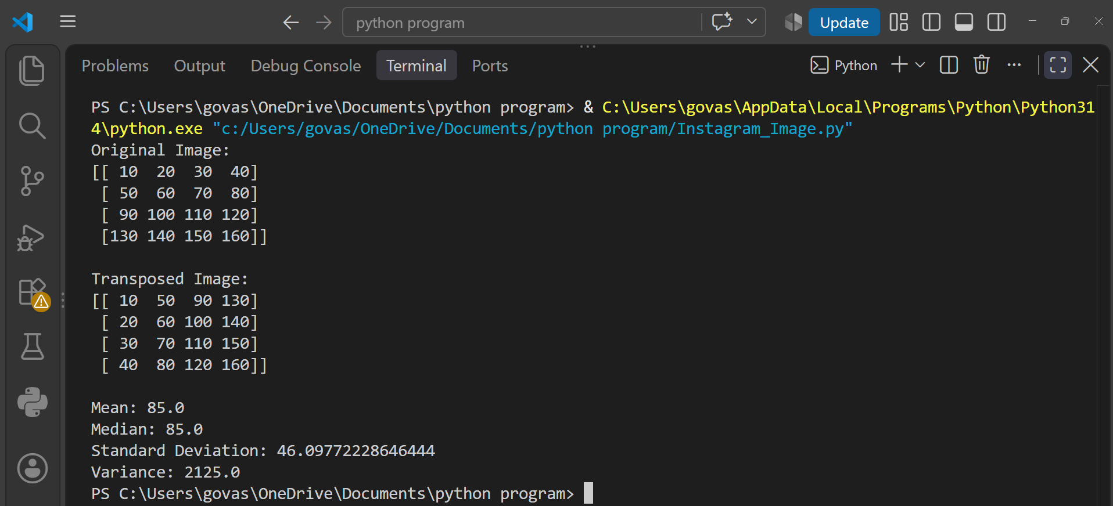

Question : 4
Take a 3x3 NumPy matrix representing a Zomato restaurant rating correlation grid and use np.linalg.inv(), np.linalg.det(), and np.linalg.eig() to compute its inverse, determinant, and eigenvalues/eigenvectors.<br><br><em><strong>Hint:</strong> If the matrix is not invertible, modify one value and try again : </em>

import numpy as np
ratings =np.array([
[4,1,2],
[1,5,1],
[2,1,6] ])
inverse =np.linalg.inv(ratings)
determinant =np.linalg.det(ratings)
eigenvalues,eigenvectors =np.linalg.eig(ratings)
print("Matrix:")
print(ratings)
print("\nInverse:")
print(inverse)
print("\nDeterminant:")
print(determinant)
print("\nEigenvalues:")
print(eigenvalues)
print("\nEigenvectors:")
print(eigenvectors)
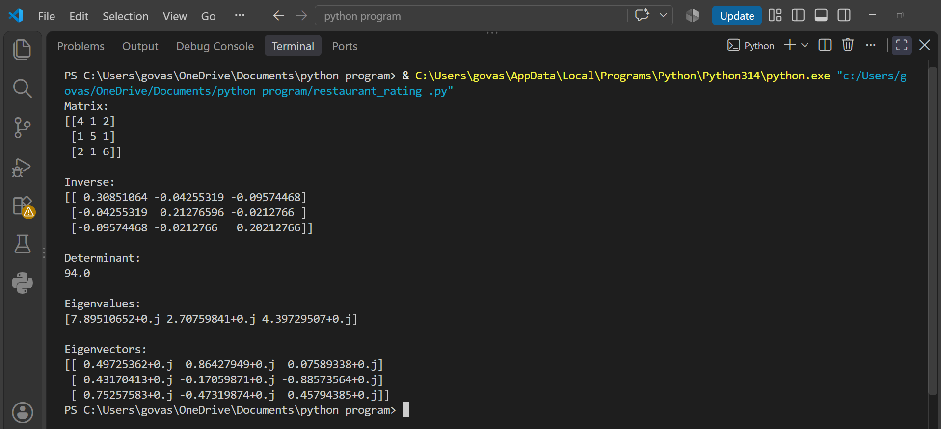

Question : 5
Create a NumPy array of shape (2, 6) representing the number of orders placed on Swiggy in two cities over 6 days. Reshape it to (3, 4), flatten it, split it into two equal parts, and then stack both parts vertically :

import numpy as np
orders =np.array([
[100,120,150,130,160,180],
[90,110,140,125,155,170]
])
print("Original Array:")
print(orders)
reshaped =orders.reshape(3,4)
print("\nReshaped (3,4):")
print(reshaped)

flattened =reshaped.flatten()
print("\nFlattened:")
print(flattened)

part1,part2 =np.split(flattened,2)

print("\nPart 1:")
print(part1)

print("\nPart 2:")
print(part2)

stacked =np.vstack((part1, part2))

print("\nVertically Stacked:")
print(stacked)

